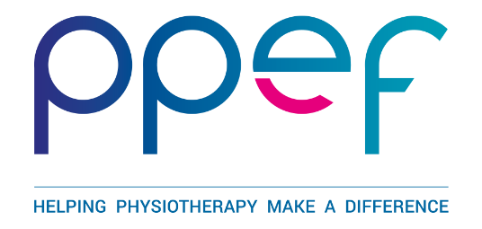
PPEF GUIDANCE NOTES FOR SCHEME B
The maximum amount available for Scheme B is £2,000. This scheme is for those undertaking individual scholarship activity or who are self-funding speakers or presenters attending a conference.
Criteria for Applicants for Individual Scholarship Awards
- All applicants must be current members of the Chartered Society of Physiotherapy and registered with the Health and Care Professions Council (HCPC) in good standing
- Applicants must give details of other financial assistance given or applied for in connection with the current proposal. Applicants are expected to keep the Trustees informed of the outcomes of any other applications
- Applicants must supply evidence that
  - they have been accepted on the course for which they are applying for funding
  - their poster or oral presentation has been accepted by the conference organisers
- Applicants may submit only one application for a programme. Previously successful applicants applying for funding for a different course will be considered
- Applications for funding should be made no more than 12-months before the proposed commencement date of the programme of study or conference presentation
- Applicants seeking funding for courses conducted overseas are unlikely to gain an award if a comparable course is available in the UK
- Whilst an award will not be given to fund participation in group trips or exchanges merely to observe overseas practices, applications will be considered from those members visiting foreign countries to research and evaluate particular physiotherapeutic methods and techniques or professional issues
- Grants and awards shall only be used for the purposes agreed by the Trustees
- Evidence of expenditure, to include receipts must be submitted to the Trustees on request
- PPEF reserves the right to demand a refund of the award if it is deemed that the funds were used for purposes other than those stated in the application or if the project is not completed

Completing the form
Justification: The quality of this statement may affect whether or not funding will be awarded. Please type on 1 side of A4 maximum, minimum font size 10.
The Justification should be presented under the three following headings:
- Justification for undertaking this particular programme / attending conference
- Relevance to your future continuing professional development
- Benefit to the physiotherapy profession.
Post graduate qualifications: Please submit details of your post-qualifying employment and education on 1 side of A4 maximum, minimum font size 10, including all relevant dates for education and employment.

